**Program no : 8**

**Program Title : Temperature sensor**

**Aim : Converts degree in Celsius to Fahrenheit**

**Hardware Required :**

* Arduino Board
* Temperature sensor(TM36)

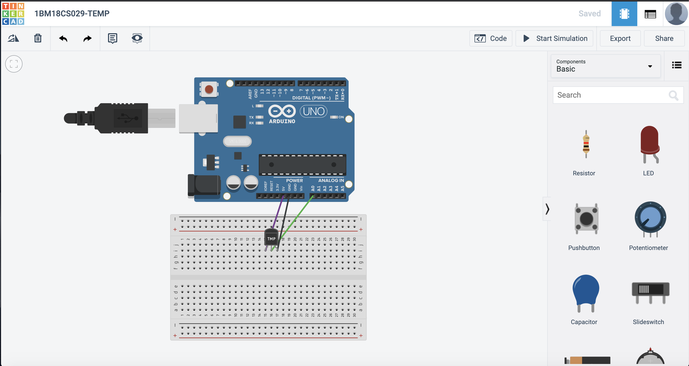

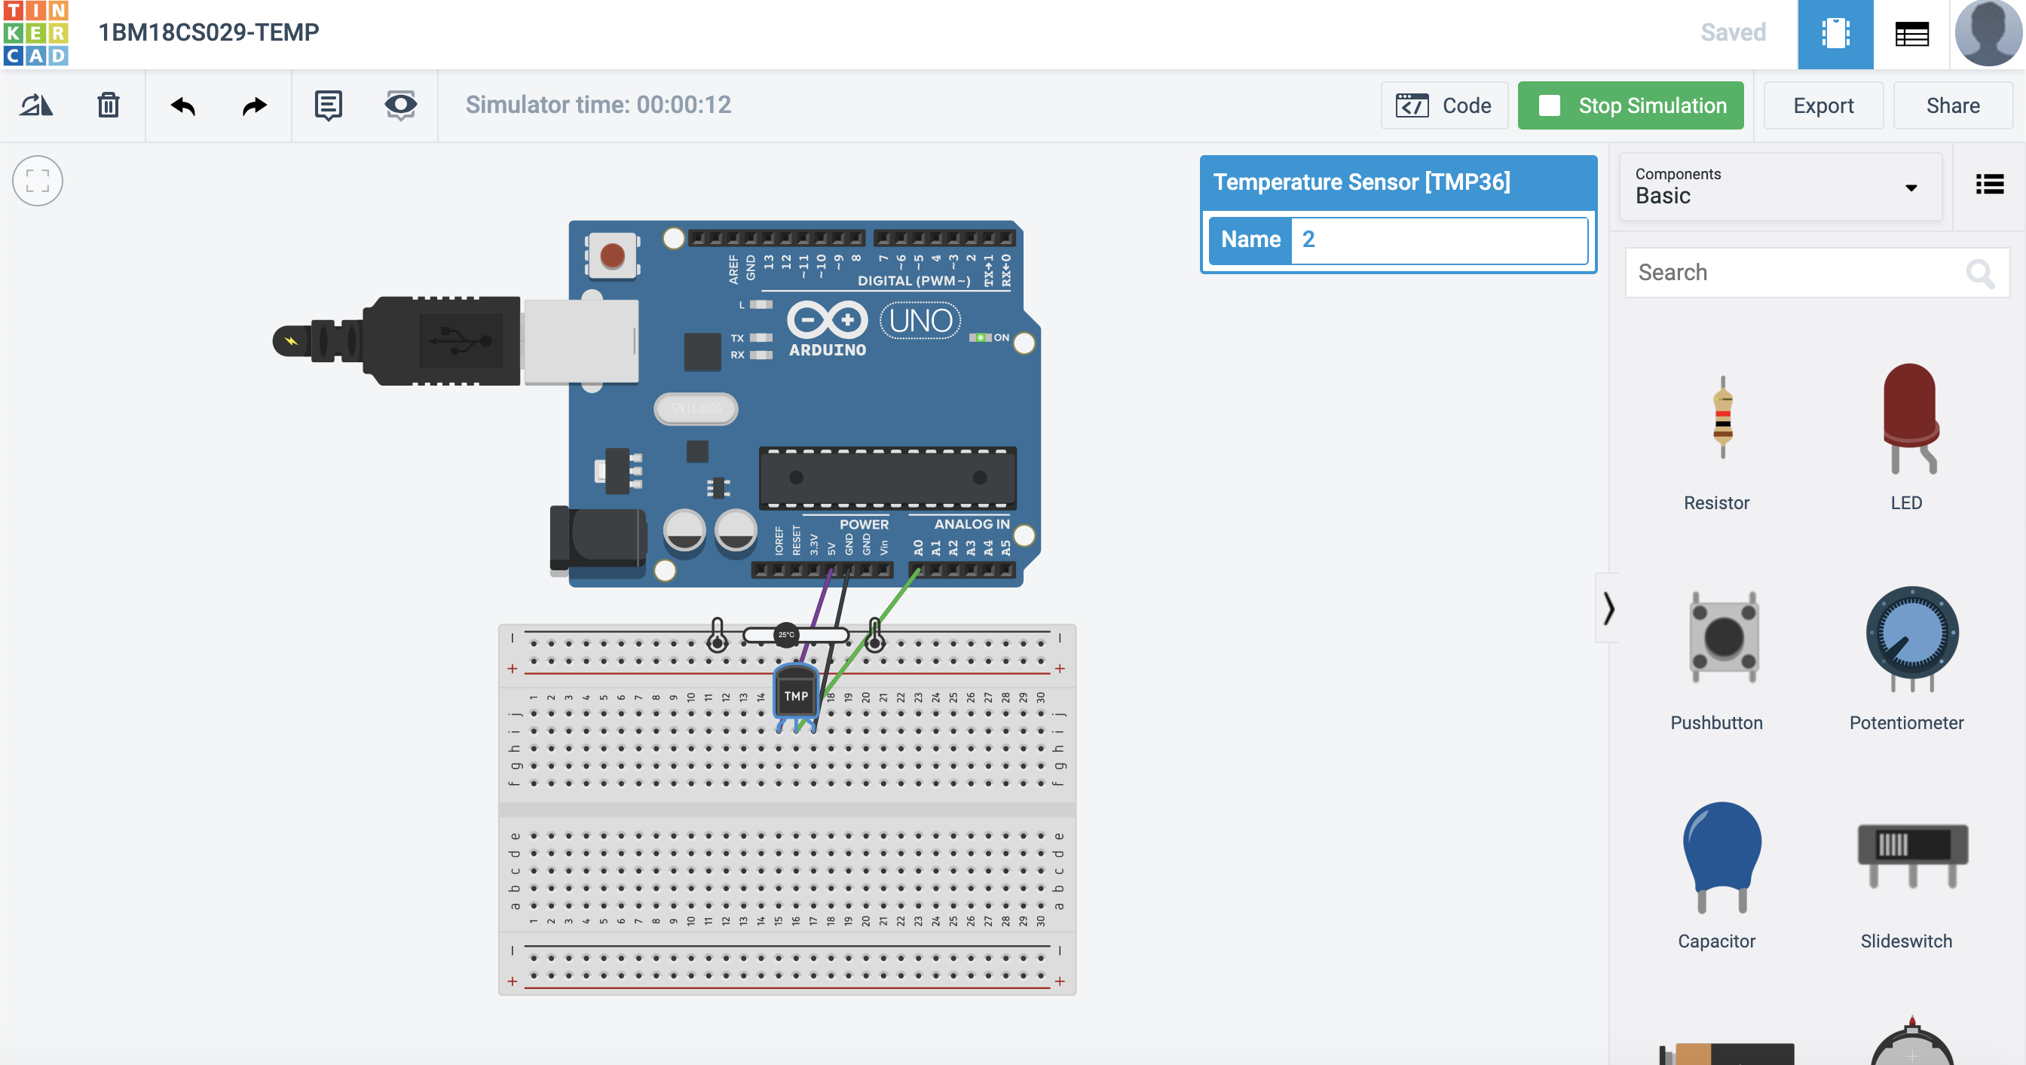

Code :

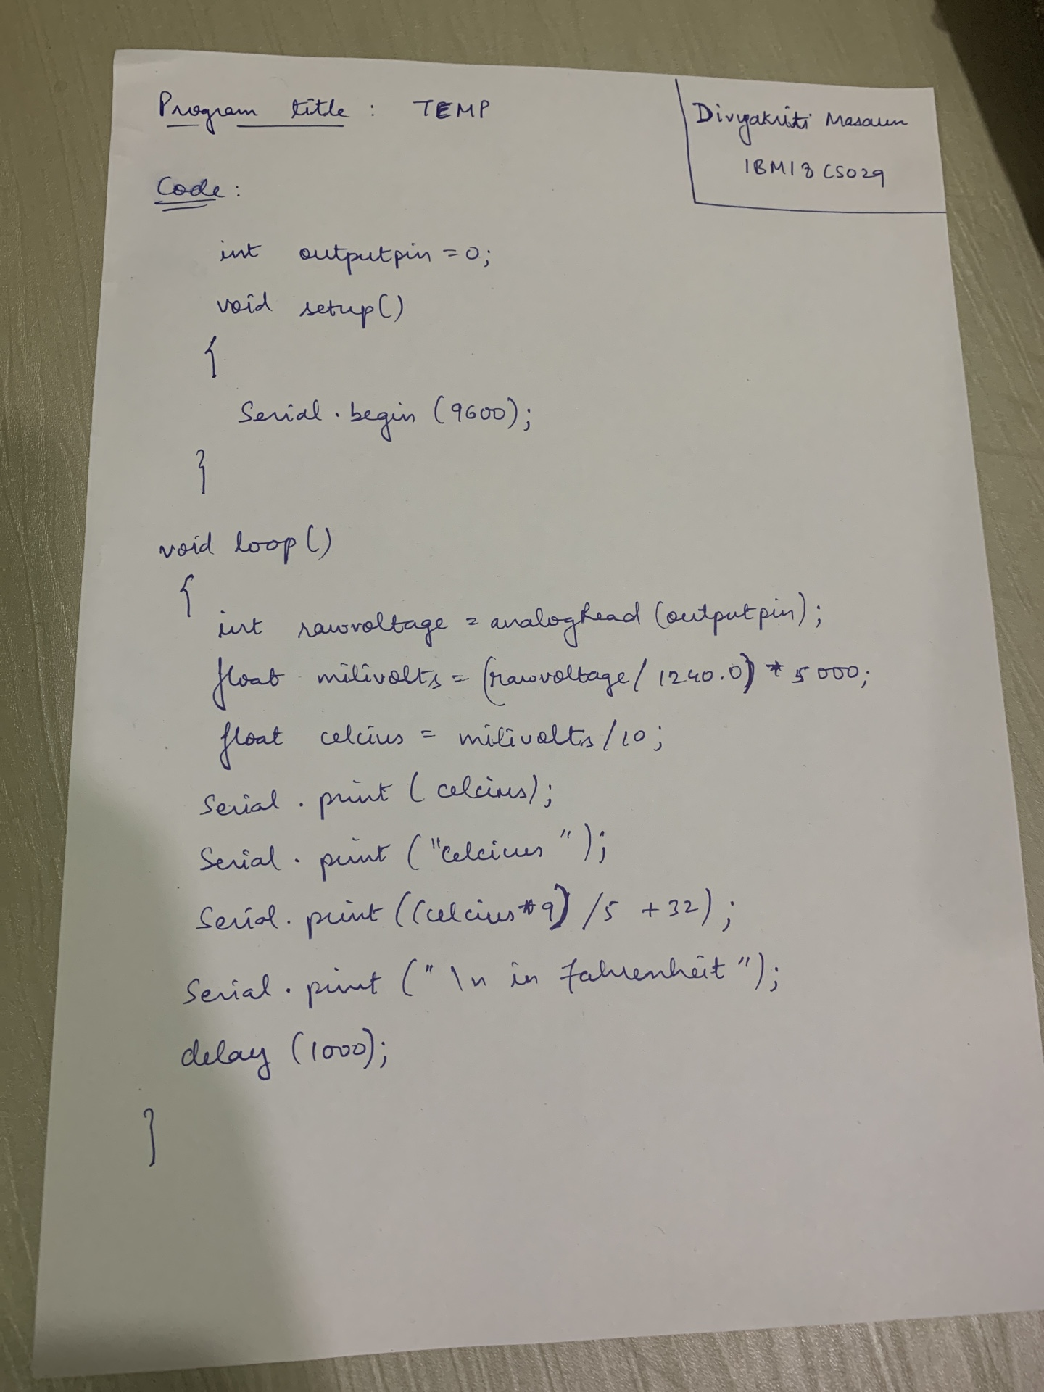

OUTPUT / OBSERVATIONS :

Converts degree in Celsius to Fahrenheit .